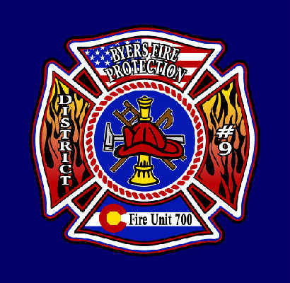

BYERS FIRE PROTECTION DISTRICT #9

100 N. Main Phone – 303.822.5208

P.O. Box 85 Fax – 303.822.5551
Byers, CO 80103 Email – admin@byersfire.org

NOTICE OF A GATHERING OF THE BOARD OF DIRECTORS
OF THE BYERS FIRE PROTECTION DISTRICT NO. 9 AND AGENDA

PLEASE TAKE NOTICE that the Board of Directors of the Byers Fire Protection District No. 9 will be gathering at 4:00 pm for an Awards Banquet and Ceremony on the evening of Saturday, the 27th day of April 2024 at May Farms located at 64001 US Highway 36, Byers, Colorado.

No business will be conducted at this gathering.

Byers Fire Protection District No. 9
R. James Shelley, Chairman

